Task 1
Task 1 Login
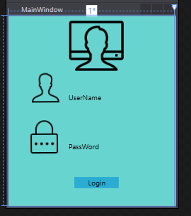
Task 1 Landing
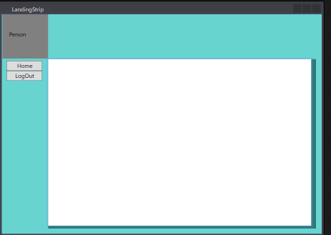

Task 1 Admin
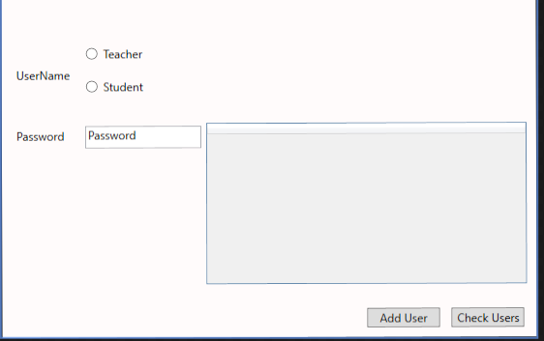
Task 1 Teacher Landing
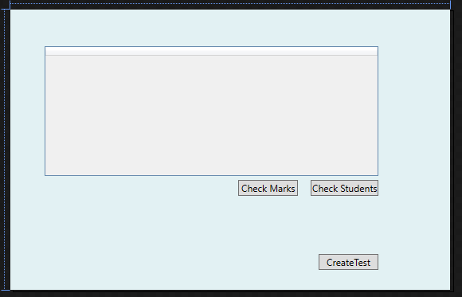

Task 1 Teacher Create Test
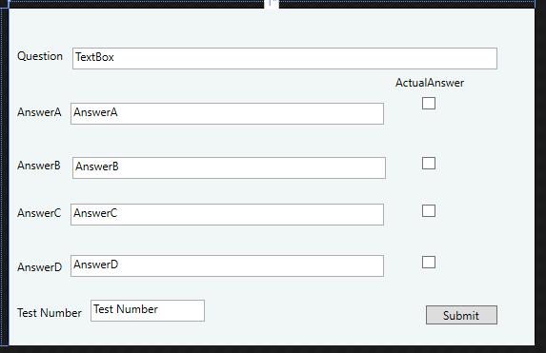

Task 1 Student Landing
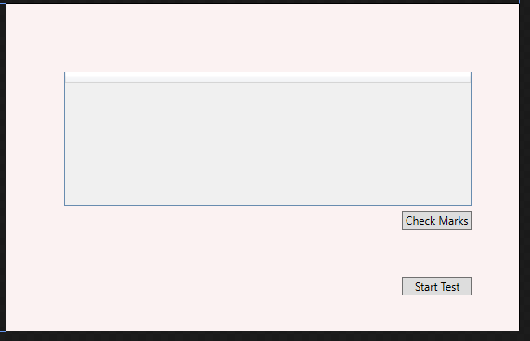

Task 1 Student Test
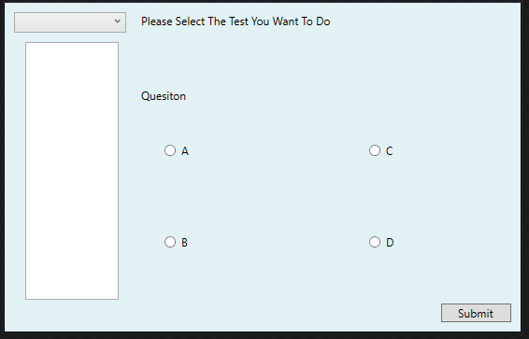

Task 2
Task 2 Admin

Task 2 Login
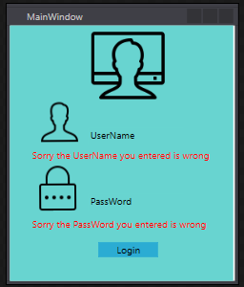
Task 2 Landing

Task 2 Teacher Landing
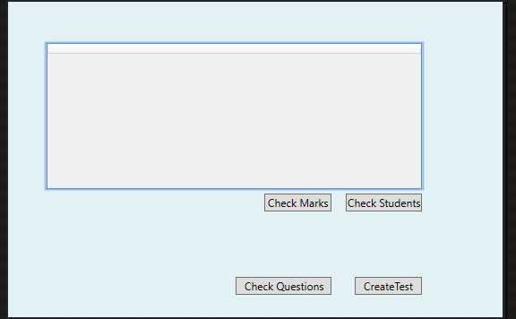
Task 2 Teacher Create

Task 2 Teacher Past Questions

Task 2 Student Landing

Task 2 Student Test

Task 3
Task 3 login
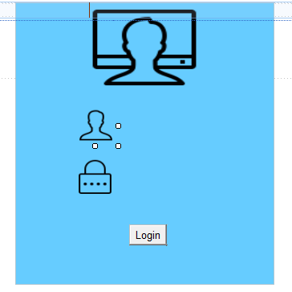

Task 3 Admin
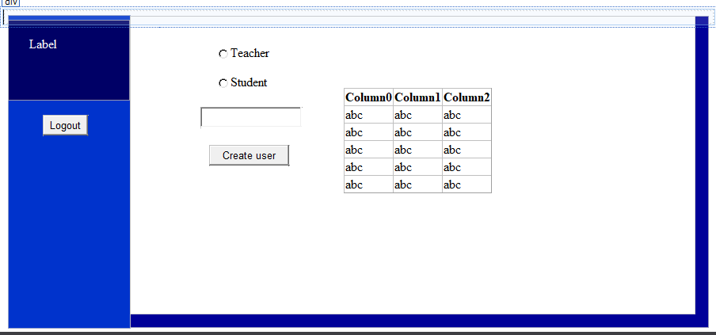
Task 3 Teacher Landing
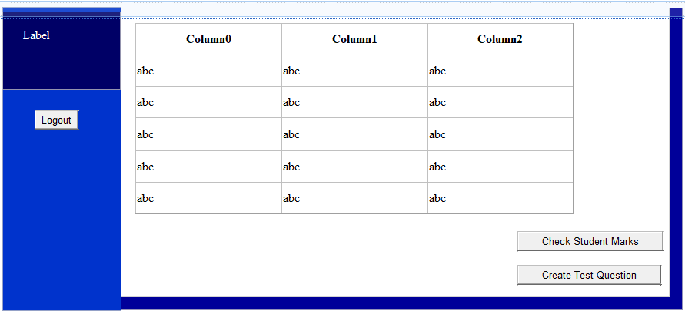

Task 3 Teacher Test Create
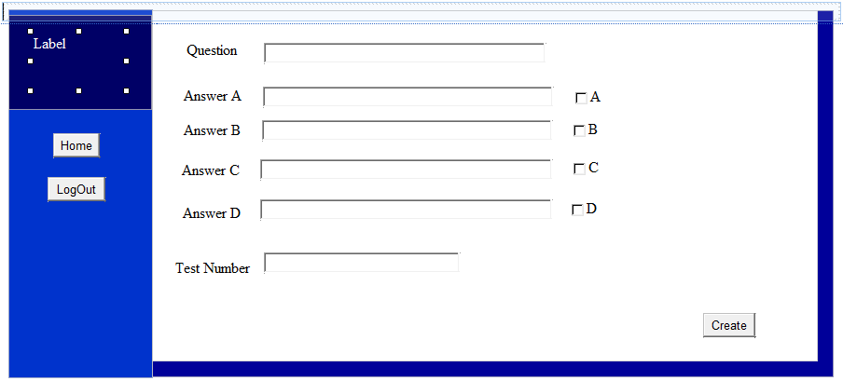
Task 3 Student Landing
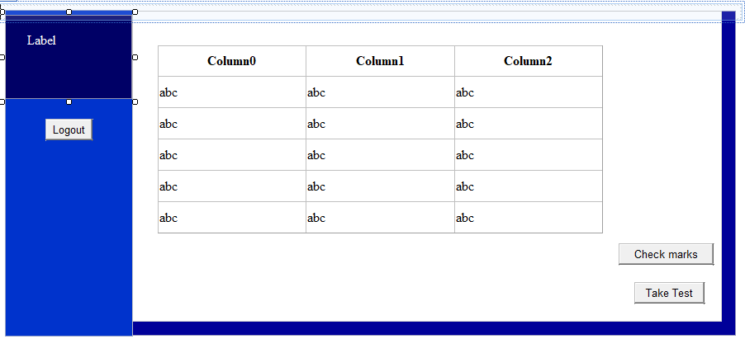
Task 3 Student Test
